## Explore sample template apps

## Get sample apps

Before you can experiment with or edit the model-driven sample apps, you must set them up in a Microsoft Dataverse database. If you have not already created a trial enviroment, follow the steps in the [Create a trial (standard) environment in the Power Platform admin center](https://docs.microsoft.com/en-us/power-platform/admin/trial-environments/) learning module. Make sure that you select the **Deploy sample apps and data** toggle.

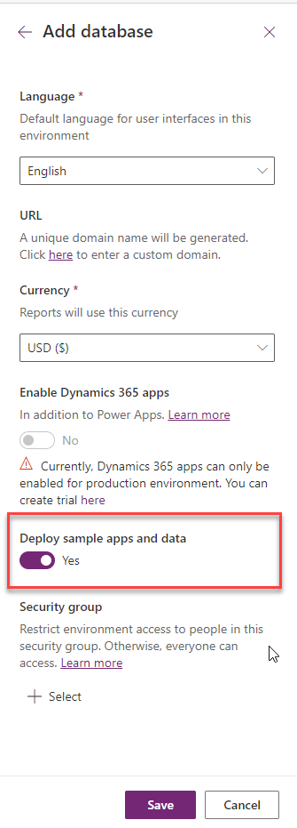

In Power Apps, select the environment you want, or go to the [Microsoft Power Platform admin center](https://admin.powerplatform.microsoft.com/) to create a new one. Select **New**, provide a name, **Yes** to Create a database for this environment, and select **Save**.

## Run a sample app

To run a sample app, follow these steps:

1. Sign in to [Power Apps](https://make.powerapps.com/) to see a list of available sample apps. For this example, select **Fundraiser**.

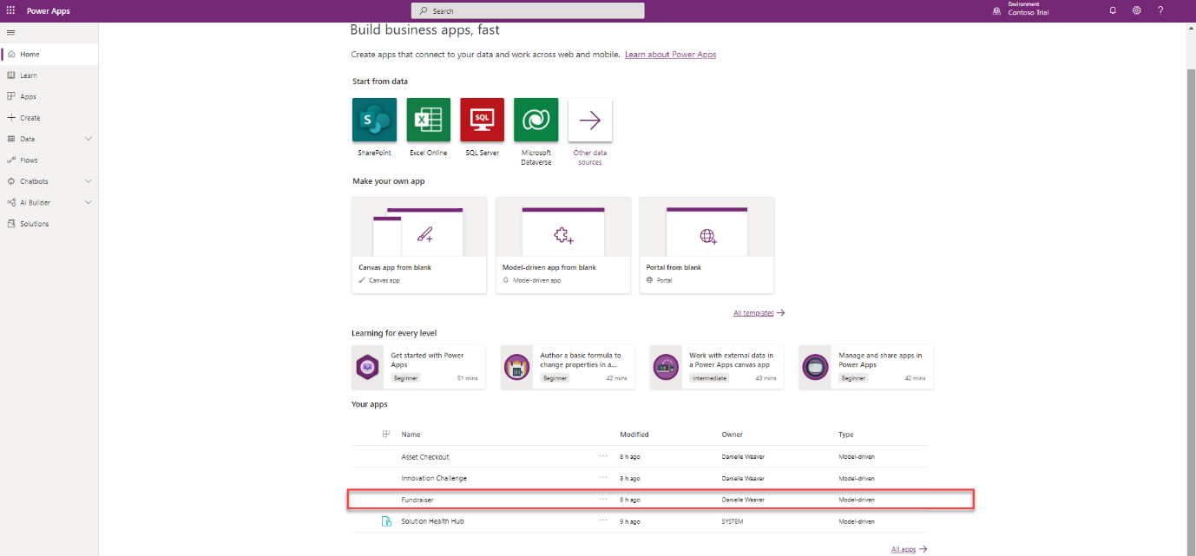

1. At the top of the page, select **Show Visual Filter** to show graphs and charts where you can see how donations to fundraisers are performing. In the next steps, you'll create a new fundraiser and submit a donation to that fundraiser.
2. On the left pane, under **Fundraiser**, select **Fundraisers**.
3. Select **+ New** to add a new fundraiser.
4. Under the **General** tab, enter the following information:

**Name** - My Fundraiser

1. In the upper-right corner, select the drop-down arrow next to **Total Donations**.
2. From the drop-down menu, enter the following information:

**Fundraiser Goal** - 500

1. On your keyboard, press **Enter**.
2. Select **Save & Close**.
3. On the left pane, under **Fundraiser**, select **Donations**.
4. Select the drop-down arrow to the right of **Other Activities**.
5. From the drop-down menu, select **Donation**.
6. Enter the following information:
   * **Subject** - My First Donation
   * **Donation Amount** - 100
   * **From** - Nancy Anderson (sample)
   * **Regarding** - My fundraiser
7. Select **Save & Close**.
8. On the left, select **Dashboards**.
9. Select **Show Visual Filter**.
10. Notice **Total Donations vs Goal by Fundraiser** shows your donation.

You have successfully run a sample model-driven app, added a new fundraiser, and added a donation to the fundraiser.